Прочитайте текст, ответьте на вопросы после него. Выпишите и переведите подчеркнутые выражения.

Sweet tooth

The British have a sweet tooth. That means they like eating sweet things like puddings and pies, jams, biscuits and buns, cakes and rolls.
For the British, any time is eat-a-sweet time: tea-break at work, break at school, watching TV at home, on a car journey, in the cinema or theatre. During holidays like Christmas and Easter, and on special days like Mother’s Day and Valentine’s Day they eat even more sweet things.

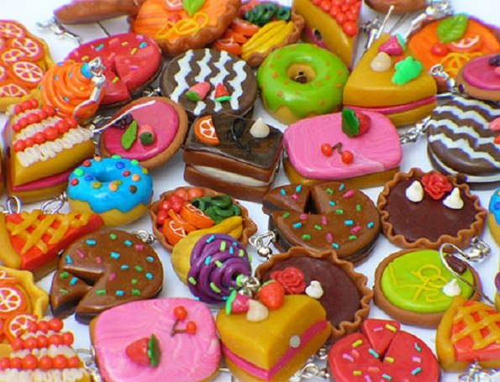

Answer the following questions:
- What do the words “the British have a sweet tooth” mean?
- What kinds of sweet things do you know of?
- What sweet things do you like?
- When do the British eat cakes, biscuits etc?
- Are sweet things good for children’s health? Why?

