Прочитайте текст, выпишите и переведите подчеркнутые выражения.
Составьте краткий пересказ текста, запишите его.

When and where did people first make cheese?
If you don't have a refrigerator, there's no way to keep milk from going bad within a few hours. Even WITH a refrigerator milk goes bad in about a week. But ancient cows and sheep and goats only gave milk part of the year, right after they had had their babies in the spring. By mid-summer their milk had all dried up. And yet milk was an important source of fat and protein for many people. How could people manage to preserve this milk to be able to eat it in the fall and winter as well?
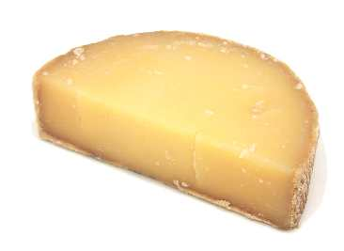
They made the milk into cheese. The easiest kind of cheese to make is yogurt, which was very common in Central Asia and in India (and still is today). If you leave milk out on a sunny kitchen counter on a warm day, it will soon get all lumpy and turn into yogurt. This is because bacteria called yeast get into the milk from the air and eat it. Some bacteria are bad for you, or make the milk taste bad. But if you get the right kind of bacteria in your milk, it turns into good yogurt. The yeast eat the lactose in the milk (a kind of sugar), break down the lactose for energy inside the cell, and then poop out what is left over: lactic acid. The lactic acid changes the part of the milk that the bacteria don't eat: the protein. Normally protein molecules are curled up in balls, but the lactic acid makes the proteins unfold, and then they get tangled up with each other, making one solid lump.

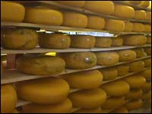
Yogurt tastes good, and it will keep for a few days without being refrigerated, but it still won't keep all winter. Once people realized how to make yogurt, they began experimenting with other types of bacteria, and found that you can use different bacteria to make aged cheeses. People were making cheese in Poland by about 5500 BC. Some of these cheeses can be kept without being refrigerated for four or five years or even more. Swiss cheese is an example of an aged cheese that you might have eaten. Or cheddar cheese. Most aged cheese is made using rennet, a piece of the stomach lining of a cow. Indo-European people in Central Asia, the first to keep cows, may also have been the first to use rennet because they were carrying milk around in empty cow stomachs and accidentally curdled it.
Because you use cow rennet to make aged cheese, in India(where cows were sacred to Hindus) people mostly ate yogurt, rather than aged cheese.
You make cheese by adding a little bit of rennet to some milk, which makes it clump up and divide into curds and whey, and then straining out most of the whey, leaving solid curds (the milk you buy at the store will work fine! You can buy rennet pretty easily). It's pretty hard to make aged cheese, but if you are interested it is not very hard to make yogurt or ricotta cheese.

